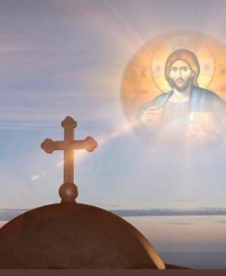  CHRISTOS NIKOS  A Greek pioneer from a far away land.  Forging a life, Dina holding his hand.  At the time he came, many would follow  Now is the time to feel our sorrow.  He made his life, Australia his home.  This big wide world for him to roam.  Australia had its own three sisters.  But then it had three sisters more.  And Chris had three girls for him to adore.  The time has come to say goodbye  An honest man, never told a lie.  The memory of CHRIS, will never die.  (Marty mou)  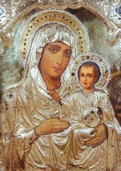  We wish to thank all who have been part of and contributed on the life journey of our beloved Christos near and far.  Burial: Woronora Cemetery Sutherland  Section: General 3- Grave 0152  Following the burial, please join the family for refreshments at Celeste Cottage Woronora Cemetery Sutherland | 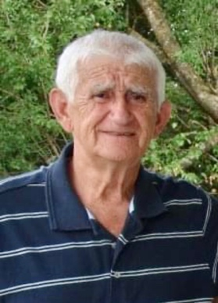  I  In Loving Memory of  Christos NIKOS  (1929-2022)  A warrior of life, with a gentle soul.  A loving man with the biggest heart.  A friend to all. A mentor to many. A philosopher of life.  A proud man who was loyal to his Greek heritage and devoted to his Australian home.  A free spirit who was dedicated to his family.  His passion for reading, poetry, history, travelling and Greek music were just a few of his pleasures.  You will always be remembered & forever in our hearts daddy mou.  The Resurrection of Christ Our Lady of Myrtles and Saint Elesa Greek Orthodox Church, Kogarah  Wednesday 6th April 2022
ΧΡΗΣΤΟΣ ΝΙΚΟΣ  Γεννήθηκε στις 29 Ιουνίου 1929 και καταγόταν από το ιστορικό χωριό Μανωλιάσσα, Ιωαννίνων. Tο γένος Παναγιώτης και Χρυσή Νίκοu.  Ο Χρήστος μετανάστευσε στην Αυστραλία με το πλοίο «Κερύνεια» το 1956 και παντρεύτηκε την επί 62 χρόνια αφοσιωμένη σύζυγό του, Κωνσταντίνα Γούση.  .  Ήταν ευλογημένοι με τα αγαπημένα τους παιδιά Χρυσή και Σπύρο, Βίκυ και Γιώργο, Γεωργία και Μάρτυ Μου. Περήφανα εγγόνια: Αναστασία, Αντώνης, Κωνσταντίνος, Έλενα, Χριστίνα και δισέγγονα Ιωάννης και Γιώργος.  Ο Χρήστος δυστυχώς απεβίωσε ειρηνικά στις Τετάρτη 30 Μαρτίου, 2022. Eτών 92.  Ο Χρήστος θα λείψει πολύ στην αφοσιωμένη σύζυγό του, τα αγαπημένα του παιδιά και τα περήφανα εγγόνια του, συγγενείς και φίλους από την Αυστραλία, την Ελλάδα, τη Σουηδία και την Αμερική.  ~ Αιωνία του η μνήμη ~ | 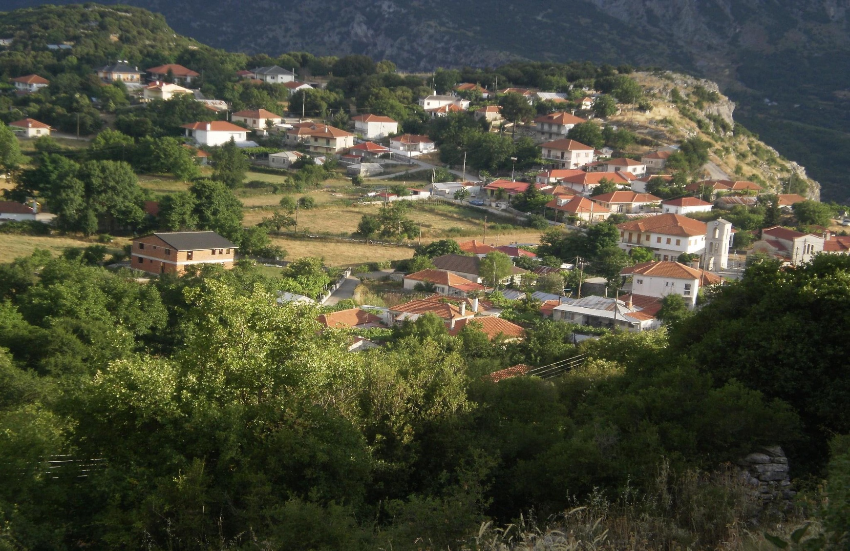  CHRISTOS NIKOS  Born in the historic village of Manoliassa, Ioannina Greece on 29th June 1929 to Panagiotis and Chrysi Nikos. Christos migrated to Australia on the ship ‘Cyrenia’ in 1956 and married his devoted wife of 62 years, Konstantina Goussis.  They were blessed with their loving children: Chrysi, Spyros, Vicky, George, Georgia, Marty mou. Proud grandchildren: Anastasia, Antonis, Kosta, Elena, Christina and great grandchildren: Ioannis and George.  Christos sadly passed away peacefully on Wednesday 30th March, 2022. Aged of 92.  Christos will be deeply missed by his loving wife, children, grandchildren, relatives and friends from Australia, Greece, Sweden and America.  ~May his memory be eternal ~  